Crater-Making Procedure

Follow these steps to make craters.

1. Make sure the string is 1.5 meters in length.
2. Measure the diameter of each of your impactors.
3. Take team positions, with the dropper standing on the chair and the material specialist spotting the dropper.
4. Have the reporter check the height of the string and make sure the setup is
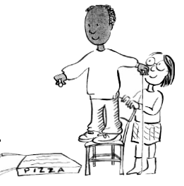
correct.
5. Drop the first impactor from the first height.
6. Carefully remove the impactor and measure the crater’s diameter.
7. Fill in the information in the chart on the worksheet.
8. Repeat procedure for the next height.
9. Repeat procedure for the next impactor.

Tips

- Remove the impactor carefully before measuring diameter.
- Be careful not to crush the crater with the ruler while you are measuring it.
Do not smooth over each crater before you make a new one.
Cratering Worksheet
Team

Date


Roles  Decide which role each team member will assume:  - Dropper: drops impactors on the surface at the direction of the recorder.  - Material Specialist: is in charge of setting up materials and safety.  - Measurer: measures impactors and crater diameters.  - Recorder: writes down group answers and checks that calculations are done correctly.  - Reporter: closely examines impacts and speaks to the class for the team.  Setup  1. Lay down the drop cloth or newspaper.  2. Place the tray in the middle and fill the tray 3 inches (about 8 centimetres) high with flour.  3. Sprinkle a THIN layer of hot chocolate powder on top using a flour sifter.  4. Move a chair close to the tray.  5. Gather the impactors, string, and rulers. | 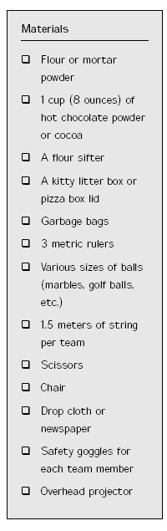

1. Observe the setup of your testing field. What does the surface look like?

2. Put two rulers on either side of an impactor and use the third ruler to
measure the distance between them. This is the width or diameter of the
impactor. Measure the diameter of all three impactors.

Ball 1 is ________ cm. Ball 2 is ________ cm. Ball 3 is ________ cm.

3. You will now make craters by following the directions on the Crater Making
Procedure Sheet.

Results

Impactor Diameter | Height | Crater Diameter
Ball 1  Diameter ______ cm | 1st try from 30 cm
Ball 1  Diameter ______ cm | 2nd try from 1.5 meters
Ball 2  Diameter _____ cm | 1st try 30 cm
Ball 2  Diameter _____ cm | 2nd try 1.5 meters
Ball 3  diameter_____ cm | 1st try 30 cm
Ball 3  diameter_____ cm | 2nd try 1.5 meters

4. Graph the results on a bar graph as shown using Excel, by copying and pasting your results:

5. How did the size of the impactor change the size of the crater?
6. How did different heights change the size of the crater?
7. Pick two different craters. How much bigger is the crater than the impactor?
Impactor Size _____________ = _____________ = ______________
Crater Size
Impactor Size _____________ = _____________ = ______________
Crater Size
8. Pick the best crater in your tray. Draw what it looks like and label the parts.

